DIGITAL LOGIC DESIGN

*LAB RECORD*

Academic Year-2022/23

Semester-III/1-Sem

Branch: SE

|  |  |
| --- | --- |
| Name | Rihana Ersanu |
| Student ID | UGR/8031/13 |
| SE-Section | 2 |

SUBMITTED TO : Dr. Mani Sarma Vittapu

SUBMISSION DATE: Jan 31, 2023.

|  |  |  |
| --- | --- | --- |
| S.No. | List of Experiments | Page No. |
| 1 | Verification of Superposition theorem | 3 |
| 2 | Verification of Norton’s theorem | 8 |
| 3 | Verification of Thevinin’s theorem | 13 |
| 4 | R-L-C Circuit Analysis | 16 |
| 5 | VI Characteristics of Diode | 19 |
| 6 | Zener Diode Voltage Regulator | 24 |
| 7 | BJT Common Base Characteristics | 30 |
| 8 | Verification of Operational Amplifier | 33 |

1. **VERIFICATION OF SUPERPOSITION THEOREM**

**OBJECTIVE:** To verify Superposition Theorem

**BACKGROUND THEORY:**

If a number of voltage or current source are acting simultaneously in a linear network, the resultant current in any branch is the algebraic sum of the currents that would be produced in it, when each source acts alone replacing all other independent sources by their internal resistances.

**Circuit Diagram:**

**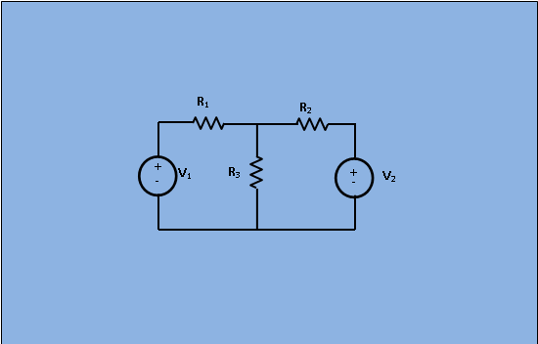         [Fig 1: Circuit for analysis of Superposition** theorem]

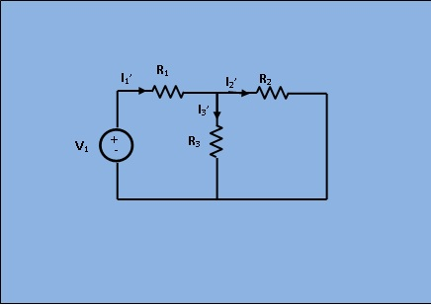

**[Fig 2: Circuit with only V2 short circuited]**

In given figure 1 apply superposition theorem , let us first take the sources V1 alone at first replacing V2by short circuit as shown in figure 2. Here,

I1′ = V1R2 ∗ R3R2 + R3 + R1

I2′ = I1′ ∗ R3R2 + R3

I3′=I1′−I2′

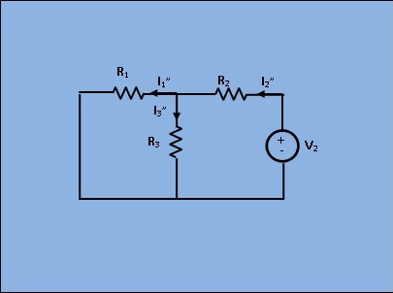

[Fig 3: Circuit with only V1 short circuited]

Next, removing V1 by short circuit, let the circuit be energized by V2 only as shown in figure 3. Then,

I2″ = V2R1 ∗ R3R1 + R3 + R2

I1″ = I2″ ∗ R3R1 + R3

I3″ = I2″ − I1″

As per superposition theorem,

I3 = I3′ + I3″

I2 = I2′ − I2″

I1 = I1′ − I1″

**Instruction:**

Set all the resistances R1, R2 and R3 and choose any arbitrary values of V1 and V2.

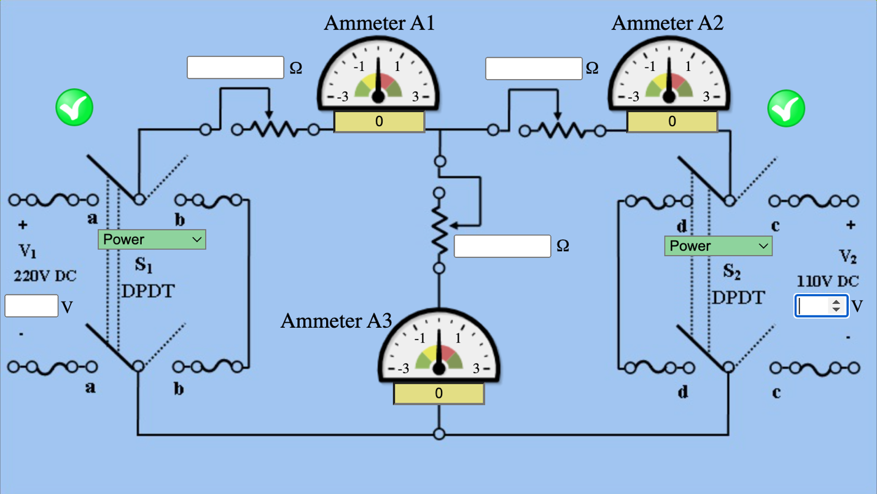

**Procedure**

**Circuit Diagram:**

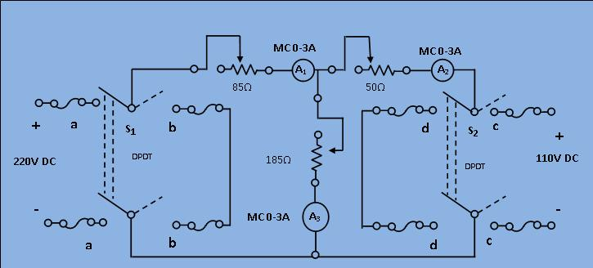

**[Fig 1: Circuit diagram of experimental set-up for verification of Superposition theorem]**

1. Connect the circuit as shown in the diagram, keeping the switches open and resistance at their maximum positions.
2. Set S1 to position "aa" and S2 to position "cc" respectively which means both the sources are energized. Note down the current \(I_1\), \(I_2\) and \(I_3\) from ammeter A1, A2 and A3.
3. Set S1 to positions "aa" and S2 to position "dd" respectively which means the, only 220V source is energized and the terminals of S2 are shorted. Note down current \(I_{1'}\), \(I_{2'}\) and \(I_{3'}\) from the ammeter A1, A2 and A3.
4. Set S1 to position "bb" and S2 to position to "cc" respectively. Which means the, only 110V source is energized and the terminals of S1 are shorted. Note down current \(I_{1''}\), \(I_{2''}\) and \(I_{3''}\) from the ammeter A1, A2 and A3.
5. Compare \(I_1\), \(I_2\) and \(I_3\) with \(I_{1'}+I_{1''}\), \(I_{2'}+I_{2''}\) and \(I_{3'}+I_{3''}\) taking care of signs properly of verify the theorem.
6. Repeat the step (2) to (6) for five different values of resistance for each three rheostats.

**OBSERVATION:**

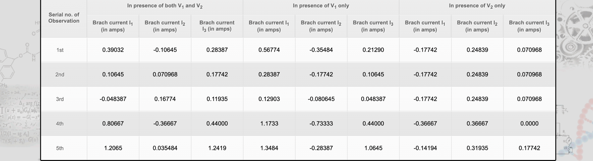

1. **VERIFICATION OF NORTON THEOREM**

**OBJECTIVE:**

* To demonstrate the Norton theorem
* To Nortonize a given circuit and obtain the value of VRL(Voltage across load resistor

**BACKGROUND THEORY:**

By using a single current source running in parallel with a single resistor, Norton's Theorem states that any linear, two-terminal network of fixed resistances and voltage sources may be replaced.

Providing Norton current (IN), which is equivalent to the short circuit current between the terminals of the original network, is referred to as the Norton current source.

The Thevenin resistance in the Thevenin equivalent circuit is represented by a single resistor known as the Norton resistance (RN). The same process used to find Thevenin resistance is utilized to find it (RTH).

If a resistance of the same value (RLoad) is connected across the terminals of the Thevenin equivalent circuit and a resistance of the same value (RLoad) is connected between the terminals a and b of the original network, the voltage across the terminals (VAB) will match. The Norton equivalent circuit can be said to follow the same logic.

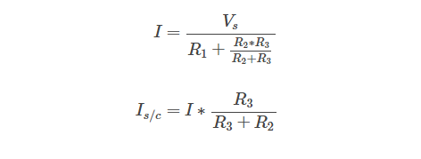

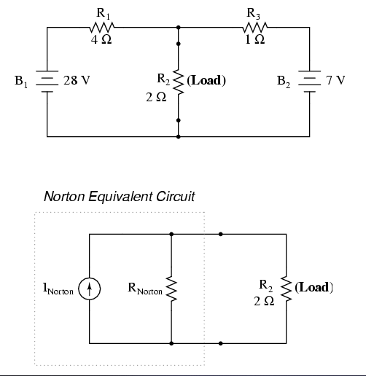

**PROCEDURE**

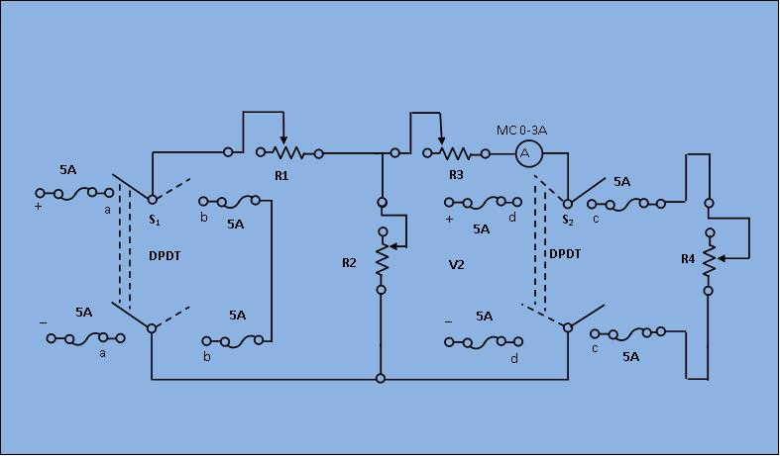

**[Fig 1: Circuit diagram for Experimental set up]**

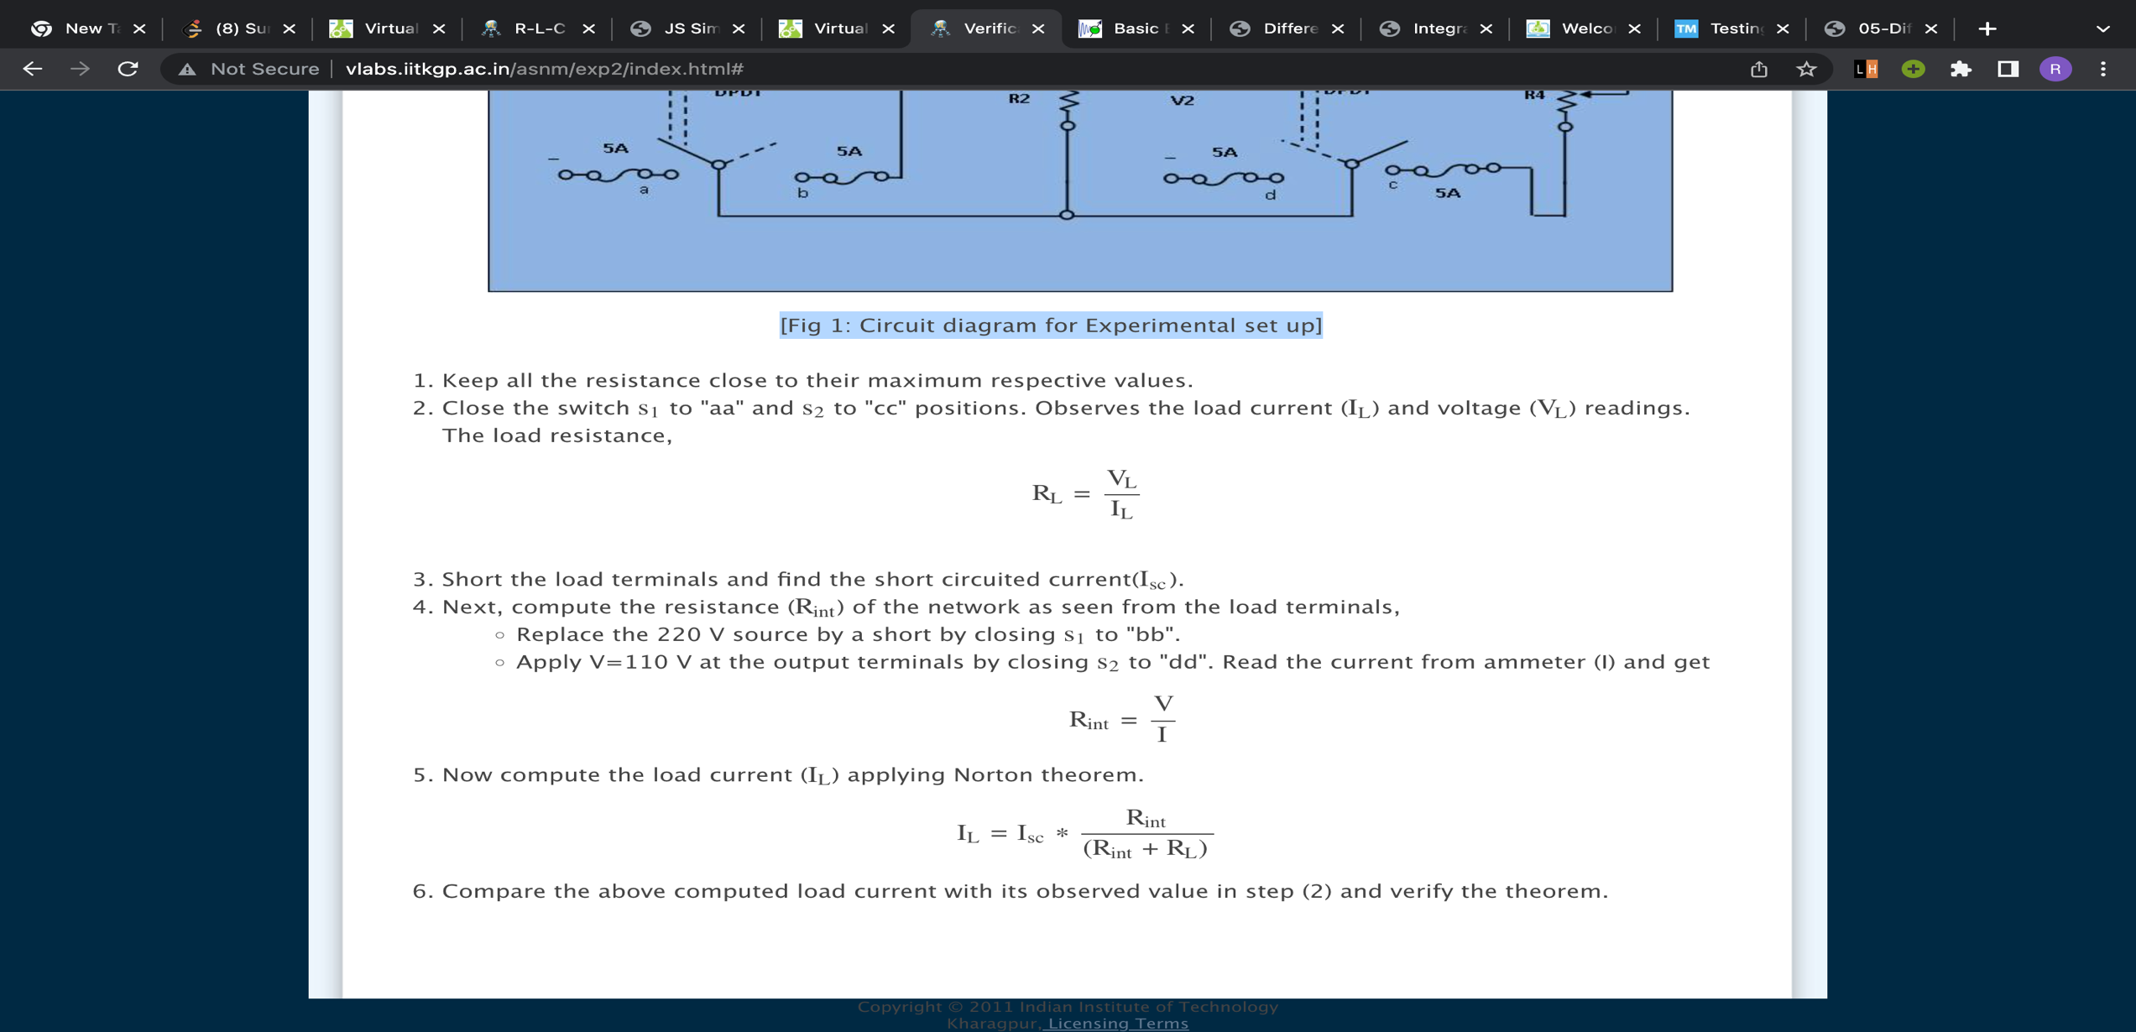

**OBSERVATIONS**

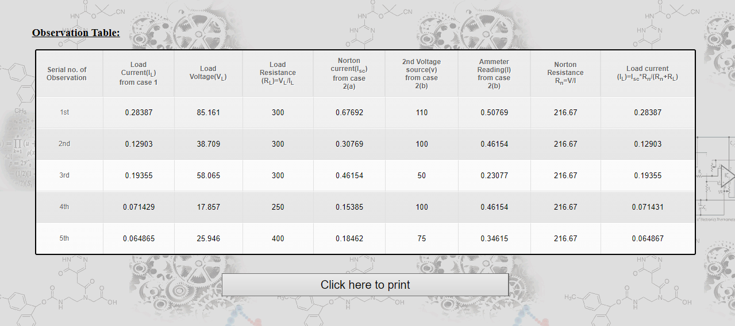

1. **VERIFICATION OF THEVENIN THEOREM**

**OBJECTIVE:**

* To demonstrate the Thevenin theorem
* To Thevenenize a given circuit and obtain the value of VRL(Voltage across load resistor

**BACKGROUND THEORY:**

A complex circuit can be reduced to a simple one by using a network's Thevenin equivalent circuit, which connects an ideal voltage source in series with a source resistance.

The voltage at the complex circuit's output when the load resistance is removed is the value of the ideal voltage source (i.e. replaced with an open circuit). Open-circuit voltage, or VOC, is the name given to the voltage source.

The resistance visible while peering into the complicated circuit's load's terminals is its series source resistance, or Thevenin equivalent circuit. Rthev or Rth, which stands for Thevenin equivalent resistance, is the designation for this resistance.

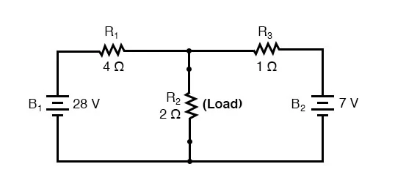

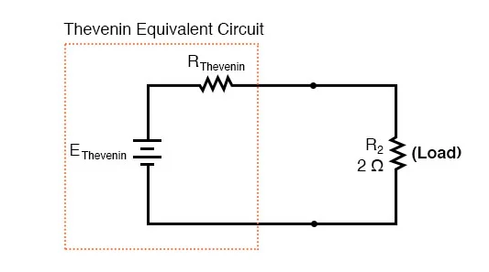

**PROCEDURE**

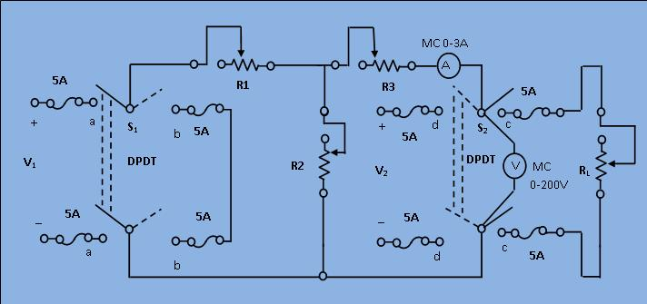

**[Fig 1: Circuit diagram for Experimental set-up for verification of Thevenin's theorem]**

1. Keep all the resistance close to their maximum respective values.
2. Close the switch S1 to "aa" and S2 to "cc" positions. Observe the load current (IL) and voltage (VL) readings. The load resistance \begin{align} R_{L} & = \frac{V_L}{I_L} \end{align}
3. Remove the load by opening the switch S2 and read the open circuit voltage (or Thevenin equivalent voltage) Vth.
4. Next, compute the resistance (RTH) of the network as seen from the load terminals,

a) Replace the 220 V source by a short by closing S1 to "bb".

b) Apply 110 V at the output terminals by closing S2 to "dd". Read the voltmeter (V) and ammeter (I) and get \begin{align} R_{th} & = \frac{V}{I} \end{align}

1. Now compute the load current. Applying Thevenin theorem \begin{align} I_{L} & = \frac{V_{th}}{R_{th}+R_{L}} \end{align}
2. Compare the above computed load current with its observed value in step (2) and verify the theorem.

**OBSERVATIONS:**

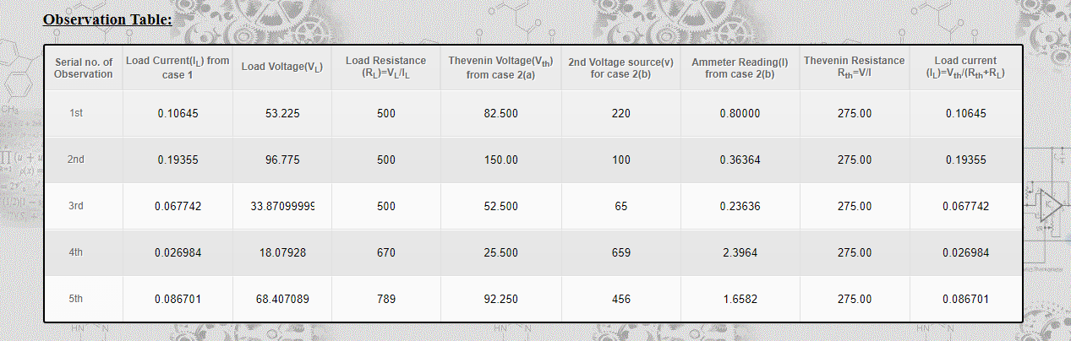

1. **R-L-C CIRCUIT ANALYSIS**

**OBJECTIVE:** To study the behaviour of a series R-L-C circuit.

**BACKGROUND THEORY:**

The most basic components of a resistor, inductor, and capacitor are connected across a voltage supply in an RLC circuit. All of these components are passive and linear in character.

Linear elements are those that have a linear relationship between voltage and current, whereas passive components are those that consume energy rather than providing it.

Although there are several ways to connect these parts across the voltage source, connecting them in series or parallel is the most popular option.

The RLC circuit displays the resonance feature in the same way that the LC circuit does, but because there is a resistor in the circuit, the oscillation in this circuit ends more rapidly than it does in the LC circuit.

* **Series RLC Circuit:**

The circuit is known as a series RLC circuit when a resistor, inductor, and capacitor are linked in series with the voltage supply.

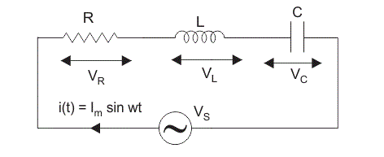

**PROCEDURES**

**CIRCUIT DIAGRAM**

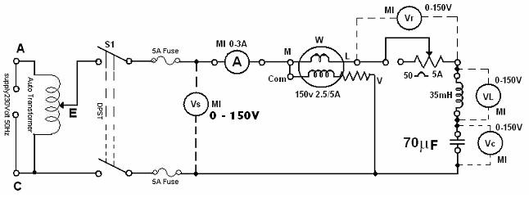

**[Fig 1: Circuit Diagram for experimental set-up of R-L-C circuit analysis]**

1. Connect the circuit as shown in the diagram in figure 1.
2. Adjust the rheostat for maximum resistance and the auto transformer to the position of zero-output voltage and switch on the supply.
3. Adjust the voltage across the circuit to about 70 V and note $I, V_s, V_L, V_C, V_R$ and $W$.
4. Adjust the rheostat for several settings and repeat step 3.
5. Adjust the rheostat to the maximum setting and change the capacitance to 140 μF and repeat step 4.
6. Compare the values of phase angle as obtained from the meter readings and from the phasor diagrams. (From the phasor diagrams compute cosθ and θ). Draw phasor diagrams showing $I, V_s, V_L, V_C,$ and $V_R$ for different sets of readings.

**OBSERVATIONS:**

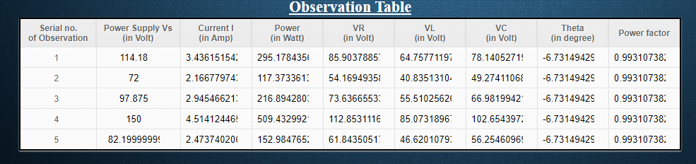

1. **VI CHARACTERISTICS OF A DIODE**

**OBJECTIVE:**

* At the end of the experiment, the student should be able to
* Explain the structure of a P-N junction diode
* Explain the function of a P-N junction diode
* Explain forward and reverse biased characteristics of a Silicon diode
* Explain forward and reverse biased characteristics of a Germanium diode

**BACKGROUND THEORY:**

A junction of n-type and p-type semiconductor material creates the diode, a device. The term "cathode" refers to the lead connected to the n-type material, and "anode" refers to the lead connected to the p-type material. A solid line is typically used to identify the cathode of a diode.

The holes in the p-type region and the electrons in the n-type region are pushed toward the junction and begin to neutralize the depletion zone, reducing its width, when the positive terminal of the battery is connected to the P side (anode) and the negative terminal of the battery is connected to the N side (cathode) of a diode.

A diode's N side (cathode) and P side (anode) are linked to the positive and negative terminals of the battery, respectively. So, until the diode fails, very little current will pass.

Battery positive and negative terminals are linked to the P and N sides of the diode, respectively, during forward biasing. Forward biasing will cause the diode to conduct since it will narrow the depletion zone and overcome the barrier potential. The forward biasing voltage must be higher than the barrier potential for a conductor to function. For a germanium diode, forward biasing causes the diode to behave like a closed switch with a potential drop of almost 0.3 V across it. a germanium diode's properties for forward and reverse bias. You can see from the graph that the diode begins to conduct when the forward bias voltage rises above about 0.3 volts (for Ge diode). This voltage is called cut-in voltage.

In reverse biasing, a diode's N side and P side are linked to the positive and negative terminals of the battery, respectively. Since reverse biasing widens the depletion region and makes it harder for current carrier charges to cross the barrier potential, the diode does not conduct electricity when reverse biased. When there is no current flowing, the diode will behave like an open switch.

1. 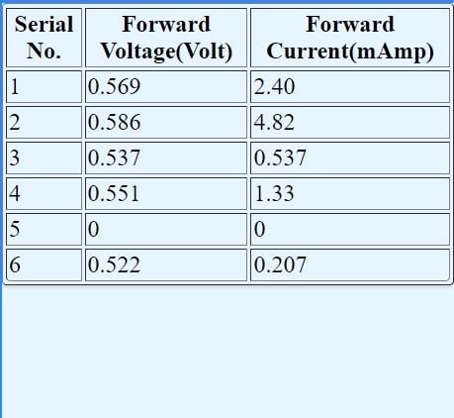

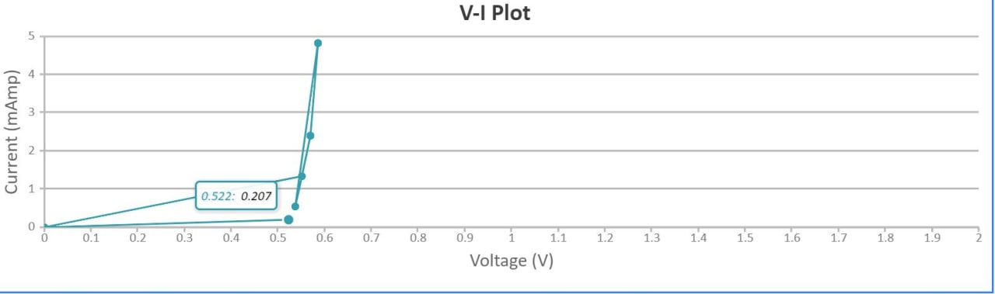

1. 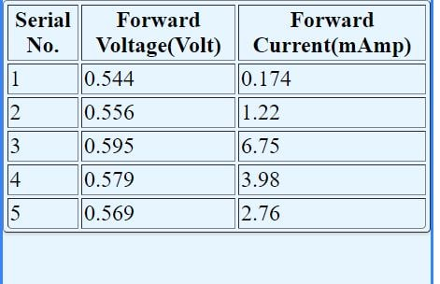

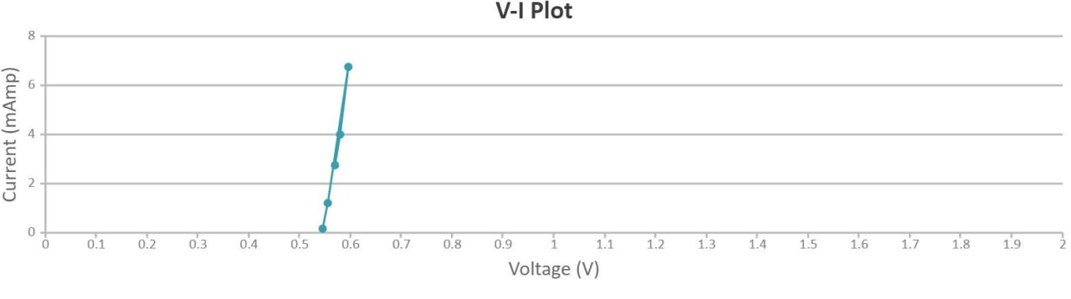

1. 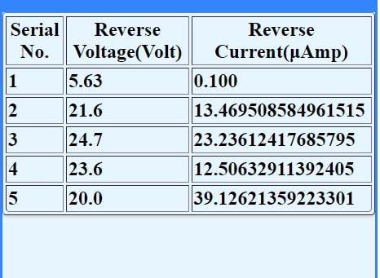

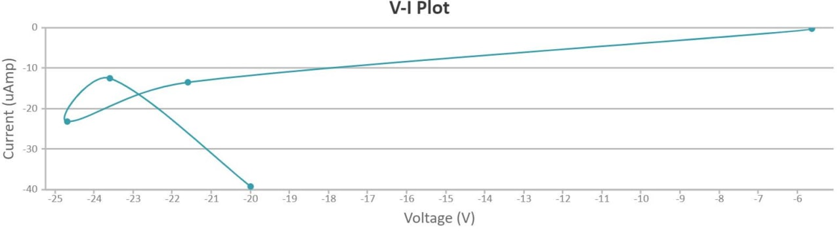

1. 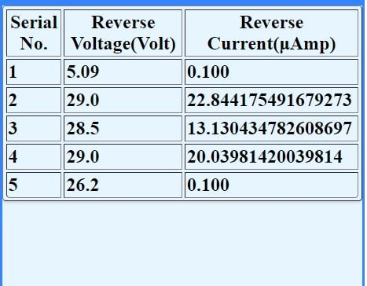

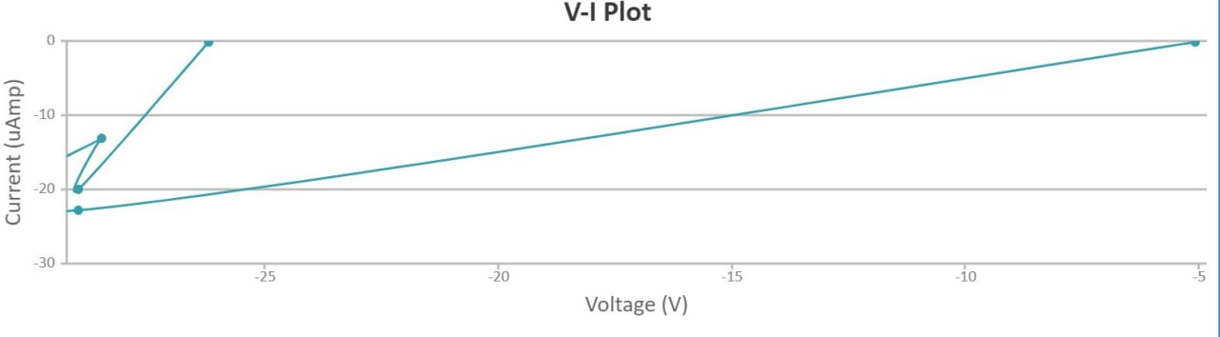

1. 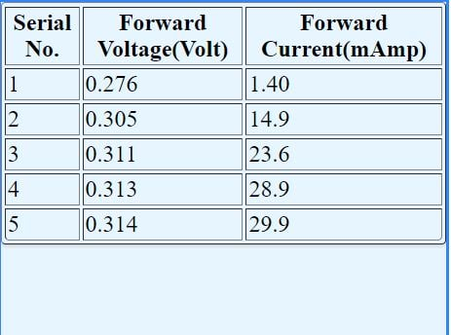

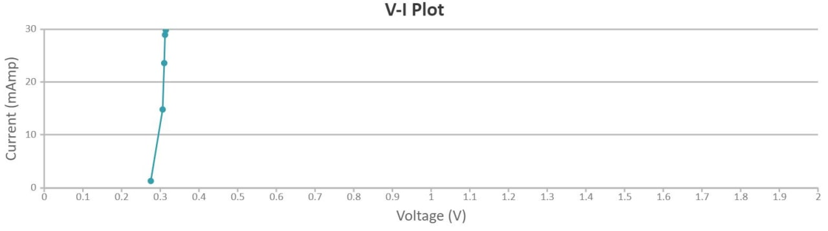

1. 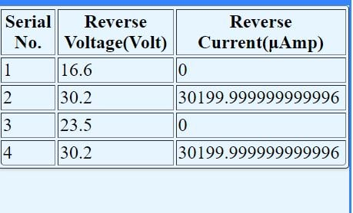

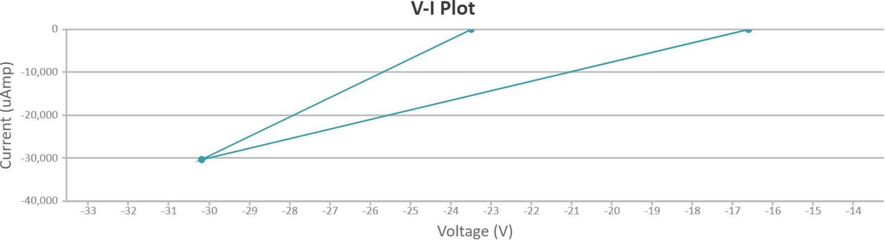

1. **ZENER DOIDE-VOLTAGE REGULATOR**

**OBJECTIVES:**

* Explain the function of a Zener diode
* Explain Zener Diode as Voltage Regulator

**BACKGROUND THEORY:**

A Zener Diode is a unique type of diode that allows current to flow normally in both directions when the voltage is below the breakdown voltage or "zener" voltage. However, it also lets current to flow normally in both directions when the voltage is above this voltage. Zener diodes are created with a substantially lower breakdown voltage.

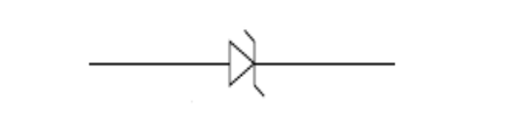

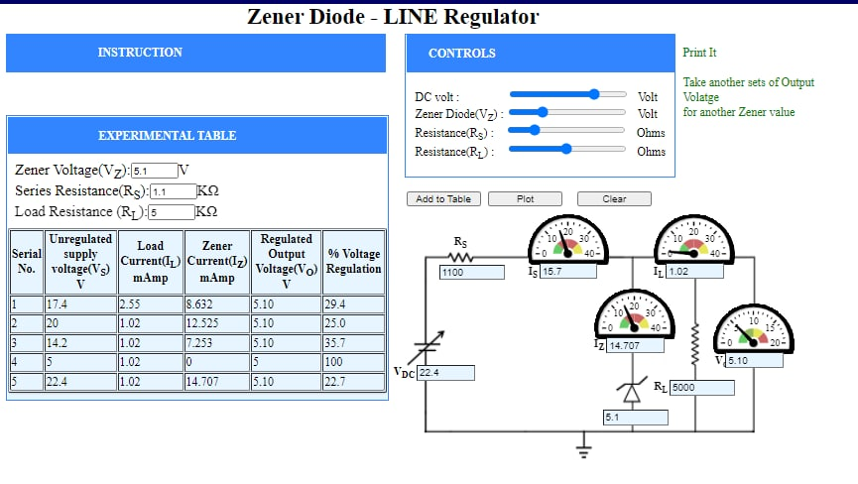

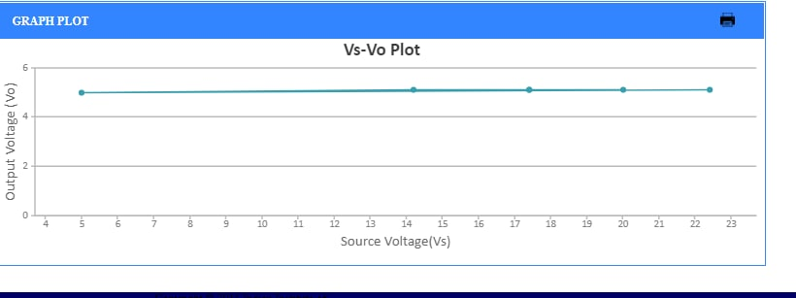

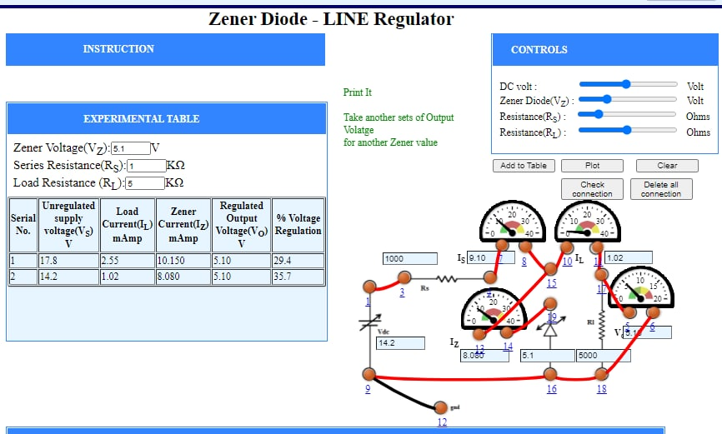

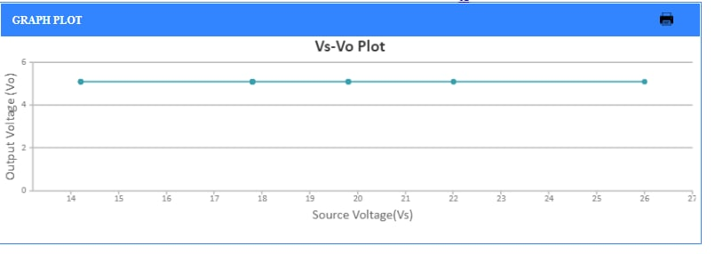

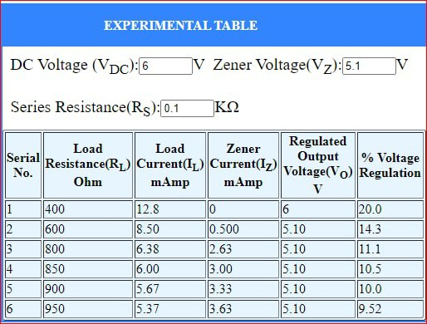

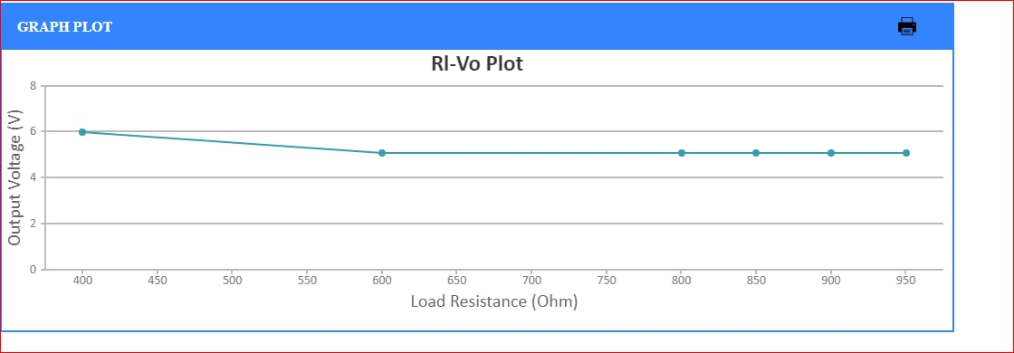

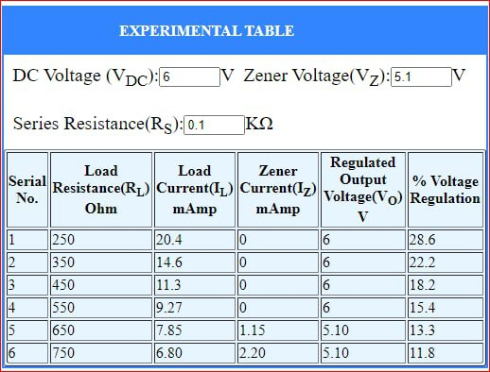

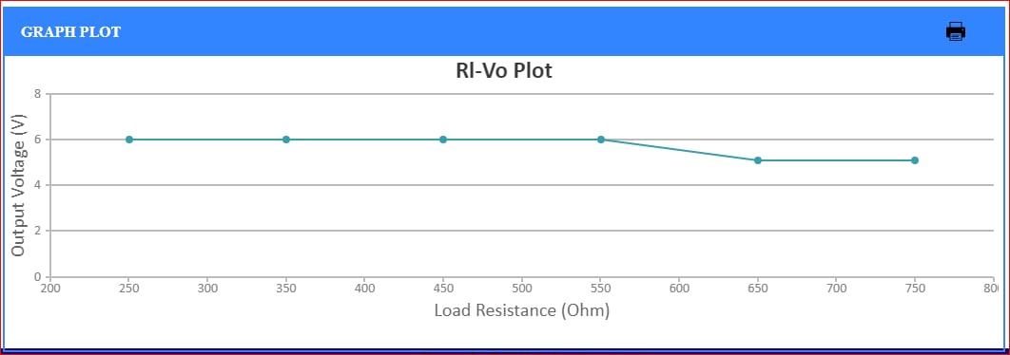

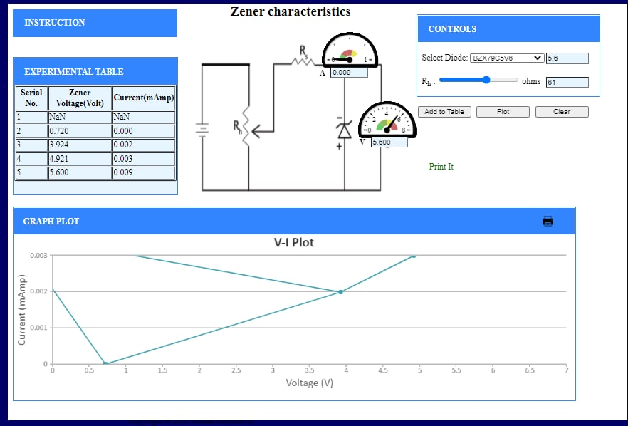

1. **BJT COMMON BASE CHARACTERISTICS:**

**OBJECTIVE:** In this lab, we'll examine a bipolar junction transistor's DC properties (BJT).

**BACKGROUND THEORY:**

One of the main components of silicon transistor technology are the three terminal devices known as bipolar junction transistors (BJTs). The emitter (E), collector (C), and base (B) are the three terminals . Figure 1 depicts the symbols for npn and pnp transistors as well as a schematic for a transistor in a TO-92 package with the pin connections for the BJT 2N4400 highlighted. A general-purpose NPN amplifier transistor is the 2N4400.

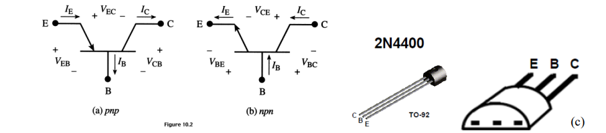

Emitter (E): The area at the left end that supplies free charge carriers, such as electrons in n-p-n transistors or holes in p-n-p transistors, is known as the emitter.

These majority carriers—holes in the n region of a p-n-p transistor or electrons in the p region—are injected into the middle region. To provide a large number of majority carriers into the base, the emitter is a severely doped area.

Base (B): This is the central area that is sandwiched between either two p-type layers or two n-type layers. This region receives the majority of carriers from the emitter region. This area is quite thin and barely doped.

Collector (C): Charge carriers are collected in the area at the right end of the diagram. When compared to emitter and base regions, this region's area is the greatest. This region's amount of doping falls in between that of the base region and the strongly doped emitter region. Transistors are utilized as switches in digital electronics applications. The majority of bipolar switching circuits employ NPN transistors.

**OBSERVATIONS:**

**Input characteristics:**

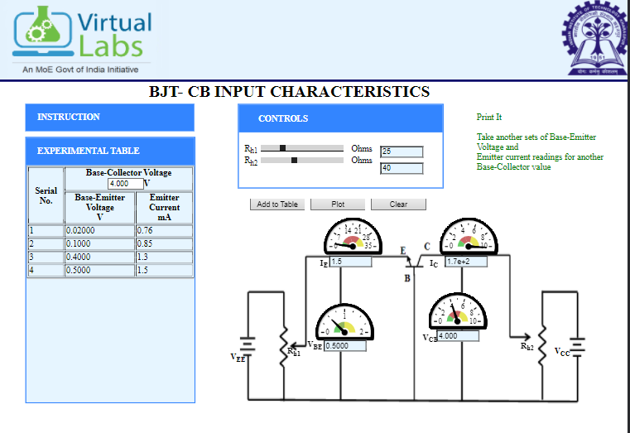

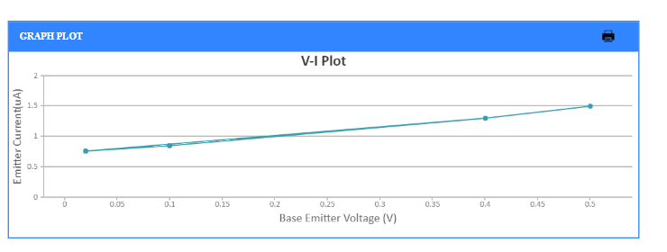

**Output characteristics:**

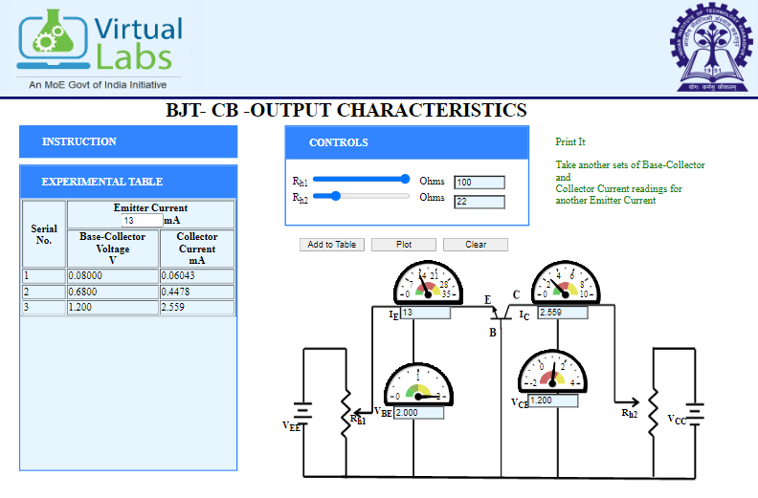

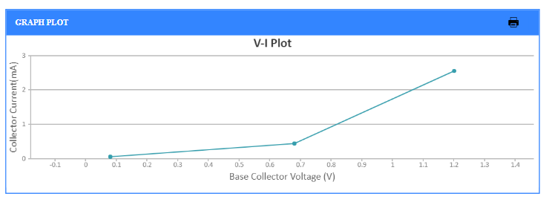

1. **Verification of Operational Amplifier**

**OBJECTIVE:**

1. Explain Differentiator using Opamp
2. Explain Integrator using Opamp

**BACKGROUND THEORY:**

An operational amplifier is an integrated circuit that can amplify weak electric signals. An operational amplifier has two input pins and one output pin. Its basic role is to amplify and output the voltage difference between the two input pins.

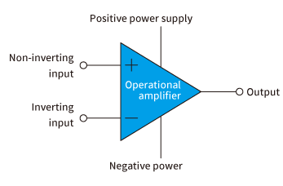

**INTEGRATOR**

Refer to the figure 1. This circuit performs the integration of the input waveform. The output voltage can be expressed as  where k is the constant of integration which depends upon the value of Vo at t = 0. The peak of the output waveform VT is given by the expression

 , where T is the time period of the input square wave. Integrators are commonly used in analog computers and wave shaping networks.

**DIFFERENTIATOR**

If the input resistor of the inverting amplifier is replaced by a capacitor, it forms an inverting differentiator. The output of the circuit is the derivative of the input. Gain of the differentiator increases with increase in frequency, which makes the circuit unstable. This is a drawback of the circuit. The output voltage Vo can be expressed as 

Differentiator functions as high pass filter. At high frequency it becomes unstable and breaks into oscillations. Input impedance decreases with increase in frequency which makes the circuit very susceptible to high frequency noise. Both stability and high frequency noise problems can be reduced significantly by additional circuit elements.

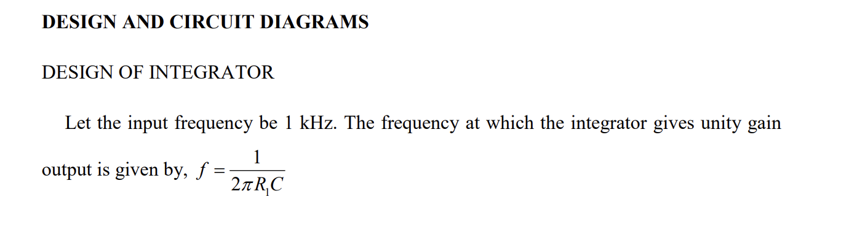

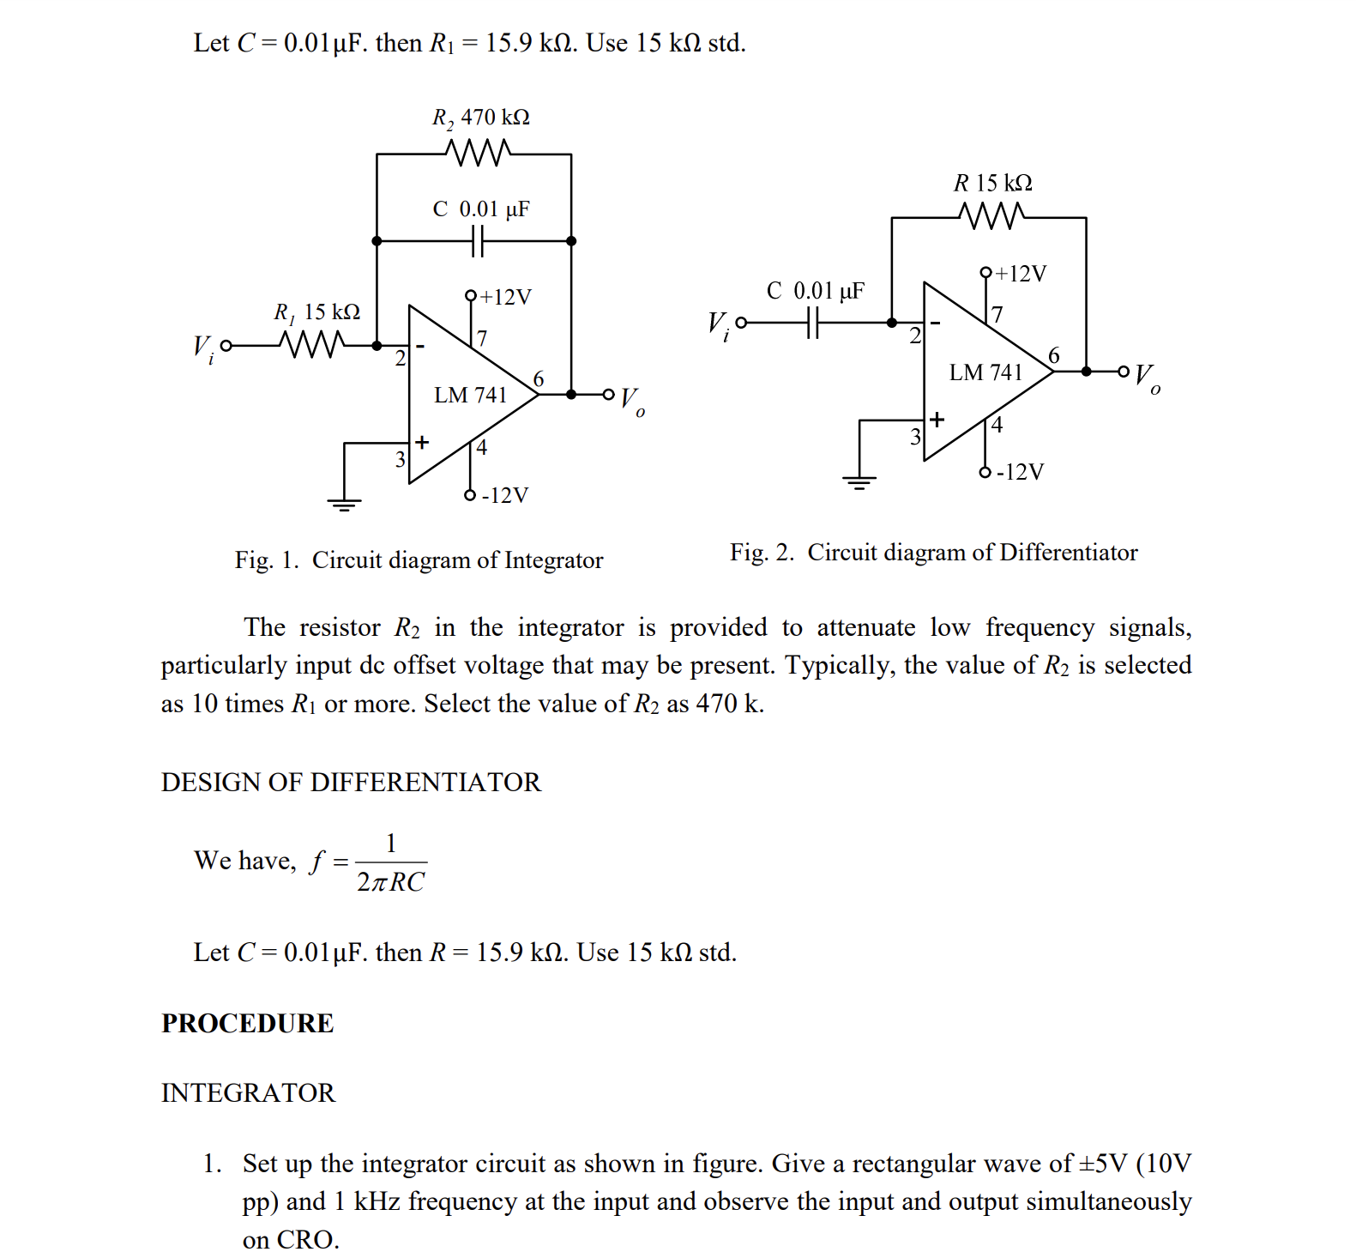

**Procedure**

**Experiment**

**Integration using OpAmp**

1. Connect the components as mentioned below:  
   L1-L7 or L1-L3, L3-L7, L4-L5, L11-L8, L12-L6, L8-L9, L4-L10.(For eg. click on 1 and then drag to 3 and so on.)
2. Click on 'Check Connection' button to check the connections.
3. If connected wrong click on 'Delete all connection' button to erase all the connections.
4. Set the resistance(R) and the capacitance (C) (Intially set R=10 kΩ and C=0.1 µF).
5. Click on 'ON' button to start th experiment.
6. Click on 'Square Wave' button to generate input waveform.
7. Click on 'Oscilloscope' button to get the output waveform.
8. Vary the Amplitude, Frequency, volt/div using the controllers.
9. Click on "Dual" button to observe both the waveform.
10. Channel 1 shows the input square waveform, Channel 2 shows the output waveform.
11. Repeat the experiment by applying 'Sine wave' as input.
12. Click on 'Sine Wave' button to generate input waveform.
13. Click on 'Oscilloscope' button to get the output waveform.
14. Vary the Amplitude, Frequency, volt/div using the controllers.
15. Click on "Dual" button to observe both the waveform.
16. Channel 1 shows the input sine waveform, Channel 2 shows the output waveform.
17. Note : Sometimes due to page load or cache, the graph may not come exact at one click. So it is better to double click on the channel-1 function/ channel-2 function/ dual function/ ground function to get the respective signals.

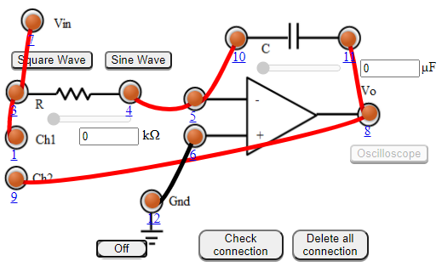

Figure:1

**Differentiator using opamp**

1. Connect the components as mentioned below:  
   L1-L7 or L1-L3, L3-L7, L4-L5, L11-L8, L12-L6, L8-L9, L4-L10.(For eg. click on 1 and then drag to 3 and so on.)
2. Click on 'Check Connection' button to check the connections.
3. If connected wrong click on 'Delete all connection' button to erase all the connections.
4. Set the resistance(R) and the capacitance (C) (Intially set R=1 kΩ and C=0.1 µF).
5. Click on 'ON' button to start th experiment.
6. Click on 'Square Wave' button to generate input waveform.
7. Click on 'Oscilloscope' button to get the output waveform.
8. Vary the Amplitude, Frequency, volt/div using the controllers.
9. Click on "Dual" button to observe both the waveform.
10. Channel 1 shows the input square waveform, Channel 2 shows the output waveform.
11. Repeat the experiment by applying 'Sine wave' as input.
12. Click on 'Sine Wave' button to generate input waveform.
13. Click on 'Oscilloscope' button to get the output waveform.
14. Vary the Amplitude, Frequency, volt/div using the controllers.
15. Click on "Dual" button to observe both the waveform.
16. Channel 1 shows the input sine waveform, Channel 2 shows the output waveform.
17. Note : Sometimes due to page load or cache, the graph may not come exact at one click. So it is better to double click on the channel-1 function/ channel-2 function/ dual function/ ground function to get the respective signals.

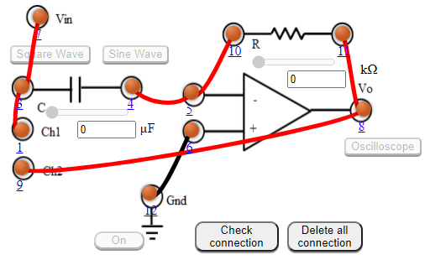

Figure:2

**OBSERVATION**

